Installing the Grafana Operator

- oc new-project grafana
- On the Openshift web console, go to Operators --> OperatorHub and search for Grafana and click on this box.
- Create an instance of Grafana CRD. You may need to use the scroll-bar at top of the window and go all the way to the right, On the resulting screen, click "Create Grafana".
- On this screen, click on YAML view radio button. Remove the contents and paste the following.
- apiVersion: grafana.integreatly.org/v1beta1
- kind: Grafana
- metadata:
- labels:
- dashboards: grafana
- folders: grafana
- name: grafana
- namespace: grafana
- spec:
- config:
- auth:
- disable_login_form: 'false'
- log:
- mode: console
- security:
- admin_password: password
- admin_user: root
- route:
- spec:
- tls:
- termination: edge
- version: 10.4.3

The status of this object does not currently show in the GUI. To make sure it installed successfully, go to the YAML definition of this object and look at the status.
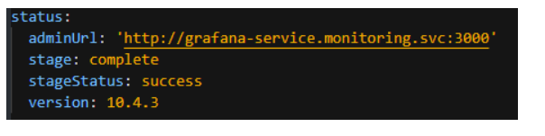

- We now need to go to the grafana project and create a service account to allow access to the cluster Prometheus metrics. To do this on the command-line, run the following:
oc project grafana

- Now, let's create a service-account, the cluster-role binding, and token.
oc create sa grafana-sa -n grafana
oc adm policy add-cluster-role-to-user cluster-reader -z grafana-sa
oc create token grafana-sa --duration=8760h
When you get the output from this command, copy and paste into notepad.
- Back in the Opensift Web Console, let's create a Grafana Datasource resource. Click "Create Grafana Dashboard". Go to YAML view and copy/paste this code:
- apiVersion: grafana.integreatly.org/v1beta1
- kind: GrafanaDatasource
- metadata:
- annotations:
- name: grafanadatasource-prometheus
- namespace: openshift-monitoring
- spec:
- allowCrossNamespaceImport: true
- datasource:
- access: proxy
- editable: true
- secureJsonData:
- httpHeaderValue1: Bearer <your token here>
- name: prometheus
- url: 'https://thanos-querier.openshift-monitoring.svc.cluster.local:9091'
- jsonData:
- httpHeaderName1: Authorization
- timeInterval: 5s
- tlsSkipVerify: true
- basicAuth: false
- isDefault: true
- type: prometheus
- instanceSelector:
- matchLabels:
- dashboards: grafana
- plugins:
- - name: grafana-clock-panel
- version: 1.3.0
- resyncPeriod: 5m

let's go to the Grafana GU
oc get route -n grafana

https://myopenshiftblog.com/openshift-virtualization-2/

